Geometry: Unit 5, Lesson H1
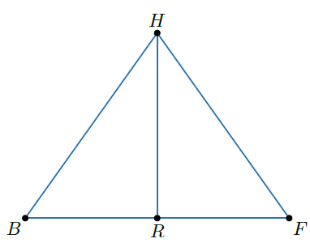
- Segment $HR$ divides triangle $HBF$ into triangles $HRB$ and $HRF$ as shown so that $\overline{BR}≅\overline{FR}$. $\overline{HB}≅\overline{HF}$. The triangles are congruent because of what?

SSS Congruence

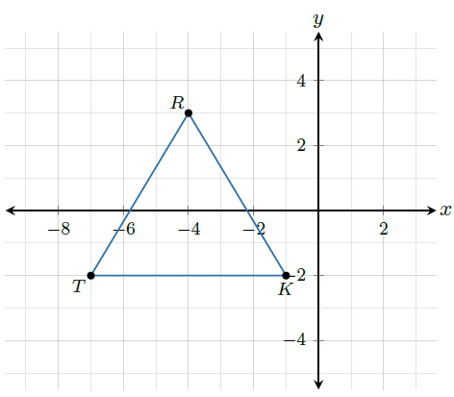
- $∆RKT$ is shown on the coordinate grid. $∆RKT$ is translated left 3 units and down 5 units to create $∆R'K'T'$. What are the coordinates of $∆R'K'T'$?

$$R^{'}\left(-7, -2\right), K^{'}\left(-4, -7\right), T'(-10, -7)$$

- The point $W$ has coordinates $(-6, 4)$. What transformation maps point $W$ onto point $W'$ with coordinates $(6, 4)$?

$$(x, y)→(-x, y)$$

